Cross-quantilogram: USDJPY and EURGBP
Method 20 / daily log returns / expanding quantiles / Alpari D1 full available history

Study setup
Logical pair: USDJPY , EURGBP
Broker symbols: USDJPY_i , EURGBP_i
Snapshot: 2026-11-03_majors_alpari_D1
Timeframe: D1
Matched return window: 1999-01-06 to 2026-11-02 (UTC bar dates)
Matched return count n: 7181
Dropped unfinished last bar dated 2026-11-03 UTC after a tick-volume check against the prior complete day.
Quantiles: expanding window, min history 252 days
tau in [0.05, 0.2]; k=0..10; headline tau=0.05, k=1
Complete matched rows (Excel): USDJPY-EURGBP_CQ_D1.xlsx
Complete matched rows (HTML table): USDJPY-EURGBP_CQ_D1_data.html

Method carried forward
The cross-quantilogram rho_tau(k) measures linkage among centered quantile-hit indicators of matched daily log returns of close, ln(close_t / close_t-1). Quotes are not inverted. At each date t, the tau-quantile uses only returns through t (expanding window) after a minimum history of 252 days. Hits are h_t = 1(r_t < q_t) - tau. rho_tau(k) is the normalized cross-product of h_x,t with h_y,t+k. Levels tau in {0.05, 0.20} and lags k=0..10 are pre-specified; headline is tau=0.05, k=1 both directions. Same-sample Pearson r is a side check. This is not causation and not a trading signal.

Results (headline)
rho_USDJPY->EURGBP(tau=0.05,k=1): 0.004529
rho_EURGBP->USDJPY(tau=0.05,k=1): 0.015643
rho_USDJPY->EURGBP(tau=0.20,k=1): 0.027358
rho_EURGBP->USDJPY(tau=0.20,k=1): 0.017211
Pearson r: -0.127992

CQ table (tau=0.05)
k | rho_USDJPY_to_EURGBP | n_USDJPY_to_EURGBP | rho_EURGBP_to_USDJPY | n_EURGBP_to_USDJPY
0 | 0.01194749 | 6930 | 0.01194749 | 6930
1 | 0.00452898 | 6929 | 0.01564303 | 6929
2 | 0.01192919 | 6928 | 0.01933863 | 6928
3 | 0.01192004 | 6927 | 0.01192004 | 6927
4 | 0.02302525 | 6926 | 0.0637779 | 6926
5 | 0.01931138 | 6925 | 0.0044921 | 6925
6 | 0.02671201 | 6924 | 0.00448288 | 6924
7 | 0.00447365 | 6923 | 0.00817854 | 6923
8 | 0.01928413 | 6922 | 0.00075951 | 6922
9 | 0.03779984 | 6921 | 0.02668496 | 6921
10 | 0.02667595 | 6920 | 0.01185598 | 6920

Conclusion
Headline tau=0.05, k=1 for USDJPY and EURGBP: rho_USDJPY->EURGBP = 0.0045; rho_EURGBP->USDJPY = 0.0156. At tau=0.20, k=1: 0.0274 and 0.0172. Same-day tau=0.05 rho(k=0) = 0.0119. Pearson r = -0.1280. This is quantile-hit linkage, not a trading signal.

Charts
Daily closes

Daily log returns

Cross-quantilogram tau=0.05
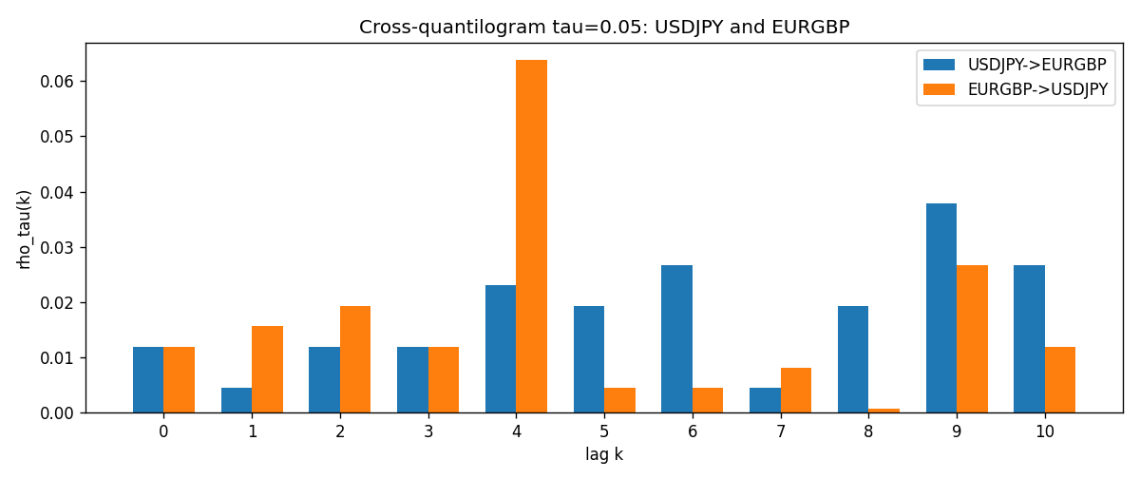

Data report
Matched rows and the CQ sheet are in the sibling Excel workbook named USDJPY-EURGBP_CQ_D1.xlsx. Embedding all rows as a Word table is impractical; this file holds column summaries and the first and last 15 matched rows.
Columns: time, USDJPY_open, EURGBP_open, USDJPY_high, EURGBP_high, USDJPY_low, EURGBP_low, USDJPY_close, EURGBP_close, USDJPY_tick_volume, EURGBP_tick_volume, USDJPY_spread, EURGBP_spread, USDJPY_real_volume, EURGBP_real_volume, USDJPY_log_return, EURGBP_log_return, USDJPY_h_t005, EURGBP_h_t005
Column summaries (matched calculation rows)
column | count | mean | std | min | 25% | 50% | 75% | max
USDJPY_open | 7181 | 113.80773 | 19.228846 | 75.693 | 104.38 | 110.98 | 120.71 | 163.824
EURGBP_open | 7181 | 0.78701429 | 0.09663819 | 0.5734 | 0.6877 | 0.83392 | 0.86523 | 0.9769
USDJPY_high | 7181 | 114.30513 | 19.290536 | 76.001 | 104.865 | 111.439 | 121.27 | 163.978
EURGBP_high | 7181 | 0.79009197 | 0.09701345 | 0.5789 | 0.6897 | 0.83701 | 0.8681 | 0.9799
USDJPY_low | 7181 | 113.28458 | 19.156841 | 75.402 | 103.87 | 110.53 | 120.172 | 163.628
EURGBP_low | 7181 | 0.78431381 | 0.09645598 | 0.5682 | 0.6857 | 0.83166 | 0.86287 | 0.9661
USDJPY_close | 7181 | 113.82069 | 19.244339 | 75.811 | 104.38 | 111.015 | 120.695 | 163.851
EURGBP_close | 7181 | 0.78705735 | 0.09663932 | 0.5735 | 0.6878 | 0.83401 | 0.86539 | 0.977
USDJPY_tick_volume | 7181 | 106398.86 | 179473.16 | 149 | 9958 | 53207 | 92916 | 1803508
EURGBP_tick_volume | 7181 | 87156.048 | 145513.65 | 154 | 6593 | 44384 | 81451 | 1424684
USDJPY_spread | 7181 | 20.250104 | 17.60648 | 0 | 6 | 11 | 30 | 50
EURGBP_spread | 7181 | 21.316669 | 19.115948 | 0 | 4 | 13 | 40 | 50
USDJPY_real_volume | 7181 | 3.4800425e+10 | 1.6097887e+11 | 0 | 0 | 0 | 0 | 3.8834203e+12
EURGBP_real_volume | 7181 | 2.788005e+10 | 1.3523257e+11 | 0 | 0 | 0 | 0 | 3.5726265e+12
USDJPY_log_return | 7181 | 4.847e-05 | 0.00620794 | -0.03908203 | -0.00320533 | 0.00011473 | 0.00340924 | 0.05184024
EURGBP_log_return | 7181 | 2.133e-05 | 0.00487349 | -0.03067367 | -0.00262366 | -0.00010035 | 0.00255918 | 0.06075387
USDJPY_h_t005 | 6930 | -0.00743146 | 0.20189686 | -0.05 | -0.05 | -0.05 | -0.05 | 0.95
EURGBP_h_t005 | 6930 | -0.01147186 | 0.19248134 | -0.05 | -0.05 | -0.05 | -0.05 | 0.95
First 15 matched rows (selected columns)
time | USDJPY_log_return | EURGBP_log_return | USDJPY_h_t005 | EURGBP_h_t005
1999-01-06 | 0.0075660159 | -0.013303338 | nan | nan
1999-01-07 | -0.012851583 | 0.011051402 | nan | nan
1999-01-08 | -0.0047719894 | -0.004943862 | nan | nan
1999-01-11 | -0.016195423 | -0.0012752393 | nan | nan
1999-01-12 | 0.032310364 | 0.0033970309 | nan | nan
1999-01-13 | 0.0081373171 | 0.00042381861 | nan | nan
1999-01-14 | 0 | -0.0019793588 | nan | nan
1999-01-15 | 0.0055343401 | -0.0076715819 | nan | nan
1999-01-18 | 8.7600193e-05 | 0.00071280921 | nan | nan
1999-01-19 | -0.0056219403 | -0.0014261269 | nan | nan
1999-01-20 | -0.0053879917 | 0.0019960086 | nan | nan
1999-01-21 | 0.0084664056 | -0.00071240297 | nan | nan
1999-01-22 | 0.0060412564 | -0.0017118406 | nan | nan
1999-01-25 | -0.0073594164 | -0.0054402425 | nan | nan
1999-01-26 | 0.0012303367 | -0.00057438255 | nan | nan
Last 15 matched rows (selected columns)
time | USDJPY_log_return | EURGBP_log_return | USDJPY_h_t005 | EURGBP_h_t005
2026-10-13 | -0.0018932826 | 0.00020130374 | -0.05 | -0.05
2026-10-14 | 7.5800166e-05 | 0.0011241873 | -0.05 | -0.05
2026-10-15 | -0.0018524319 | -0.00087557391 | -0.05 | -0.05
2026-10-16 | -0.00037976126 | -0.0020380844 | -0.05 | -0.05
2026-10-19 | 0.0034946841 | -0.00056950988 | -0.05 | -0.05
2026-10-20 | -0.0022546642 | -0.0035906254 | -0.05 | -0.05
2026-10-21 | -0.00032883504 | -0.00140647 | -0.05 | -0.05
2026-10-22 | -0.0085942669 | -0.0018743924 | -0.05 | -0.05
2026-10-23 | 0.00035080446 | 0.00082421033 | -0.05 | -0.05
2026-10-26 | 0.0041238746 | 0.00013133309 | -0.05 | -0.05
2026-10-27 | 0.0027651658 | -0.0019957343 | -0.05 | -0.05
2026-10-28 | -0.00095679538 | 0.00066967224 | -0.05 | -0.05
2026-10-29 | -0.00038043789 | -0.0011722209 | -0.05 | -0.05
2026-10-30 | -0.0010596481 | -0.0024205543 | -0.05 | -0.05
2026-11-02 | 0.0026438521 | 0.00089940465 | -0.05 | -0.05

